How to Revise
Revision should never be unpleasant, but it should be hard work, remember you’re resilient, tough and have all the skills and tools you need… go climb a mountain and don’t quit till you’re on the top!
- Ditch the social media (for now)
Block-site, copy and paste any and all social media access from your laptop into this and every time you get tempted to check (for half an hour) your messages, this will stop you. You’d be surprise how much time is wasted by students messaging each other about how they are doing revision…
https://chrome.google.com/webstore/detail/block-site-website-blocke/eiimnmioipafcokbfikbljfdeojpcgbh?hl=en
- Ditch the phone (into another room)

Move your charging point away from your study area and away from your bedside, phones and their apps are proven to release chemicals in the brain that make you happy, these are habit forming and addictive; you need to be studying not checking your phone every 5 mins for a new distraction. The light from mobile phones and TV’s also stop the release of sleepy chemicals which stop you from sleeping.

Try it as a study tip for the next month and you might improves your mood, sleep and anxieties.
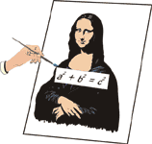
- Plan and start revising early
— i.e. months, not days before the exam. Make a timetable to plan your revision and stick to it using this great planner. https://getrevising.co.uk/planner Make sure you include plenty of short breaks!
- Don't spend ages making your notes look pretty
— this is just wasting time. For diagrams, include all the details you need to learn, but don't try to produce a work of art. Limit yourself to 2 or 3 colours so you don't get carried away colouring things in.
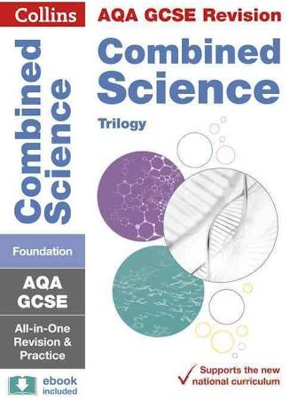
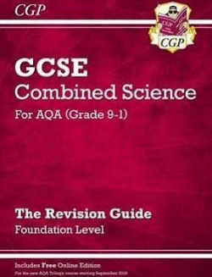
- Take short breaks
— every hour, not every 10 minutes.
- Use revision guides

These two are pretty good, but any up to date AQA labelled revision guide will do, plus you’ve already been given a free one this year.
- In study leave, start revising early
i.e. 9am — that way you'll get your day's work done much quicker and will have time to relax in the evening.
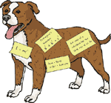
- Stick revision notes all around your house
so in the exam you think — "aha, chemical equations, they were on the fridge..."
- Get yourself drinks and snacks
so you don't make excuses to stop every 10 minutes...
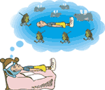
- Try reading difficult bits in funny accents
— Australian is particularly good... It worked for my friend Alice (the weirdo).
- Sit at a proper desk
Don't try to revise in bed — you'll be in the land of pink igloos and elephants before you can say "Captain Birdseye".

- Don't put it off
"Procrastination" is the long word for it. And it means rearranging stuff on your desk, getting a sudden urge after 16 years to tidy your room, playing the guitar, thinking about the weekend, writing love poems about that girl/boy you fancy, painting your toenails, etc, etc, etc,... Sit down at your desk and GET ON WITH IT.
- Don't just read your notes
Remember D.I.R.T
- Diagnose – Your weaknesses and then focus on them.
- Investigate – Discover and find materials to help you understand it, the crazier the better!
- Revise – Use any method you can find that works! Don’t stick with a method that you hate or doesn’t work, remember revision should never be unpleasant.
- Test/Teach – find a way (past papers are perfect) to test your self, if you think you’ve mastered it find a way to teach someone else (if you can explain it to someone in primary school you’ve cracked it!)

Remember, this is all about forming a revision habit, repeat as many times as you can then reward yourself, then repeat it some more, before you know it D.I.R.T revision will become your favourite hobby!
- Don't turn yourself into a revision zombie
— if you stop doing anything else but revision you'll turn into a zombie. It's really important that you keep time to do things you enjoy... like cinema, shopping, sports, frisbee, rock-climbing, making model planes, nose-picking, whatever tickles your ferret... When you're doing these try to relax and totally forget about revision.
- Do lots of practice exam papers
This is especially important as you get close to the exams
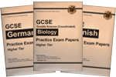
- Read the exam timetable properly
— double-check so you don't miss an exam and have plenty of time to prepare for it.
- Find the right environment to revise
NOT in front of the TV. NOT listening to the radio. Music without lyrics keeps the brain focussed, trance, classical, film scores, instrumental etc.
Try nesting yourself, build an area where your revision is never tidied away, set up for instant revision, 5 minutes here and there adds up to big gains!
- Make sure you’re enjoying it!
Not everyone exactly enjoys revision but make sure you are at least not unhappy, its basic psychology, if you make it unpleasant experience you’ll find it much more difficult to stick to.
Make a game of it, invite (productive) friends over, reward yourself with small treats and always have your next target in front of you ready to go!

