 | KS3 | KS4 | KS5
Life and Dignity of the Human
Person

All created in the image and
likeness of God
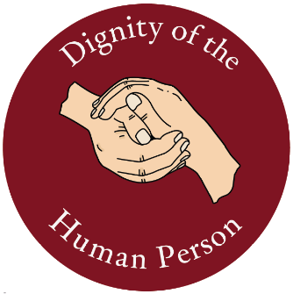
Call to family, community and  participation  Whatever is needed for each person to flourish  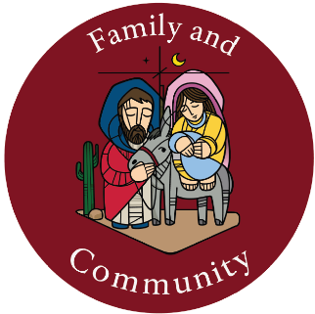 | Key Stage 3 Money Matters: For example, the feeling of excitement and delight that student experience when they are able to solve questions, they one found difficult or even impossible to solve. | Transformations and symmetry  Mathematics helps students to make informed decisions in life, based on the skills and confidence gained from choosing the most appropriate method in solving problems. These skills are transferrable to real-life situations, and therefore help the students become reflective, responsible and insightful individuals. | Hypothesis testing Pure 2  For example, the feeling of excitement and delight student experience when that are able to solve questions, they once found difficult or even impossible to solve.
Solidarity and the common good  Not just doing things for other people but acting with them to build a more just  world together  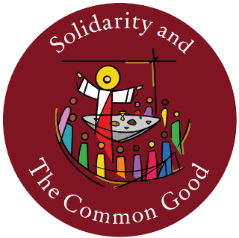 | Ratio and proportion  They discuss and plan a task, divide it up into smaller questions, and share these out amongst themselves according to each other’s strengths. They develop team building and a sense of responsibility, which are important skills that will be used in everyday life. | Transformations and symmetry  Mathematics helps students to make informed decisions in life, based on the skills and confidence gained from choosing the most appropriate method in solving problems. These skills are transferrable to real- life situations, and therefore help the students become reflective, responsible and insightful individuals. | Indices/surds  Mathematics is constantly applied to real-life scenarios these practical task give students the opportunity to understand and respect each other’s cultural, spiritual and traditional practices.
The dignity of work and the  rights of workers  As far as possible, decisions should not be taken at the highest levels but by the people who are most affected  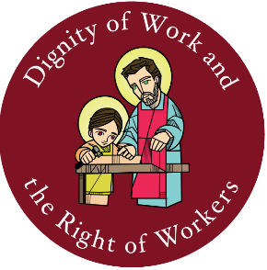 | Probability  In Mathematics, they learn to develop a sense of purpose, through the ability to investigate a hypothesis, consider other view points and ethical issues, discuss their work logically and get their findings and opinion across sensibly. | Sequence  In Mathematics, students learn how to organise their work in a systematic way, so that it can be understood by others as well as themselves. | Integration  In Mathematics, students learn how to organise their work in a systematic way, so that it can be understood by others as well as themselves.
Stewardship of God’s creation  We are called to care for creation as stewards, not just as  consumers  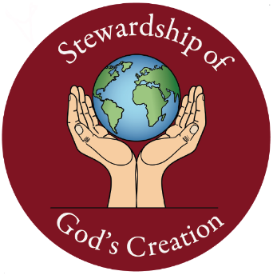 | Transformations and symmetry  Mathematics helps students to make informed decisions in life, based on the skills and confidence gained from choosing the most appropriate method in solving problems. These skills are transferrable to real-life situations, and therefore help the students become reflective, responsible and insightful individuals. | Construction and Pythagoras  Mathematics is constantly applied to real-life scenarios (Real life Maths) – these practical tasks give students the opportunity to understand and respect each other’s cultural, spiritual and traditional practices. | Logarithms  They discuss and plan a task, divide it up into smaller questions, and share these out amongst themselves according to each other’s strengths.  They develop team building and a sense of responsibility, which are important skills that will be sued in everyday life.
Rights and
responsibilities

When one person has a right, others have a responsibility to
uphold that right
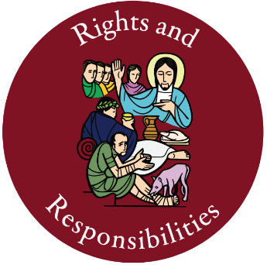

Option for the poor and the
vulnerable

To choose to consider the needs of the poorest and most
vulnerable people
first

