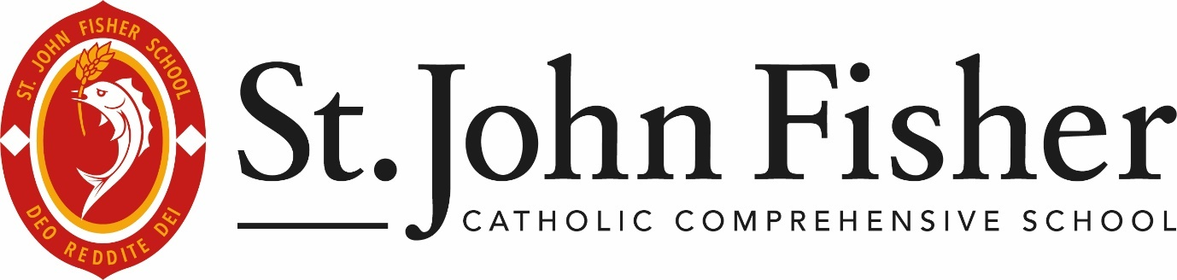

REMOTE EDUCATION INFORMATION FOR PARENTS AND CARERS
This policy should be used in conjunction with the school’s Feedback and Assessment Policy and Children With Health Needs Who Cannot Attend School Policy

The Mission Statement:
‘St. John Fisher Catholic Comprehensive School inspires students, spiritually and educationally, forming them through Faith so they can achieve their aspirations and contribute to their community.’

Date of Review: | March 2026
Date of Ratification: | 27th April 2026
Date of Next Review: | April 2027
Chair of Governors: | Mr. O. McColgan
Policy Approving Body: | Quality of Education Committee
Policy Owner: | Ms. V. Walker
Statutorily Published on Website: | Yes

Remote Education Policy – Information for Parents and Carers
This information is intended to provide clarity and transparency to pupils and parents or carers about what to expect from remote education where national or local circumstances require entire cohorts to remain at home.

What should my child expect from immediate remote education in the first day or two of pupils being sent home?
All pupils have access to TEAMs groups for their individual lessons. Teachers will ensure that lesson resources are present on the TEAMs pages for pupils to continue their learning even when not in the classroom.

Following the first few days of remote education, will my child be taught broadly the same curriculum as they would if they were in school?
Live lessons will be delivered via Microsoft Teams where appropriate. We teach the same curriculum remotely as we do in school wherever possible and appropriate. However, we have previously needed to make some adaptations in some subjects. For example, some practical subjects have components that cannot be delivered online.

How long can I expect work set by the school to take my child each day?
We expect that remote education (including remote teaching and independent work) will take pupils broadly five hours each day.

How will my child access any online remote education you are providing?
Instructions on accessing remote learning can be found on our website at https://stjohnfisher.school/learning/remote-ed/

How will my child be taught remotely?
We use a combination of the following approaches to teach pupils remotely:
- live lessons delivered via Microsoft Teams
- recorded teaching (e.g. Oak National Academy lessons, video/audio recordings made by teachers)
- commercially available websites supporting the teaching of specific subjects or areas, including video clips or sequences
- long-term project work and/or internet research activities
- teachers are expected to share their lesson materials on Microsoft TEAMs. This will allow all pupils to continue their learning when not in the classroom.

Engagement and feedback: what are your expectations for my child’s engagement and the support that we as parents and carers should provide at home?
- It is expected that pupils engage in the work set by/ shared by teachers.
- If pupils are struggling to access the work then they can communicate with the teacher via TEAMs; please be aware though that responses may not be instant.
- It is expected that parents provide support where possible by setting routines to support their child’s education.

How will you assess my child’s work and progress?
Feedback can take many forms and may not always mean extensive written comments for individual children. For example, whole-class feedback or quizzes marked automatically via digital platforms are also valid and effective methods, amongst many others. Periodically, students will be asked to complete independent pieces of work, known as ‘You Do’ tasks. These will be reviewed by their teacher who will then deliver an online feedback task to address significant whole-class misconceptions. For further information on the frequency and methodology of this approach, please see the ‘Feedback and Assessment Policy’.

Remote education for pupils who are unable to attend school for medical reasons, independent of their peer group.
Where individual pupils need to self-isolate but the majority of their peer group remains in school, how remote education is provided will likely differ from the approach for whole groups. This is due to the challenges of teaching pupils both at home and in school.

If my child is not in school because they are self-isolating, how will their remote education differ from the approaches described above?
Students who are unable to attend school for medical reasons, independent of their peer group, will be able to access lesson resources on Microsoft Teams. For further information regarding long-term absences, please request a copy of the policy ‘Pupils With Health Needs Who Cannot Attend School.’

Monitoring, Review and Evaluation
The content of this policy is based on the DFE template, ‘Providing Remote Education to Parents’, which is available online at https://www.gov.uk/government/publications/providing-remote-education-information-to-parents-template.

This policy will be reviewed annually by the SLT Lead in charge of teaching and learning and any material changes submitted for approval to the Quality of Education Committee.

The school will monitor the impact of this policy through collection of student and staff voice and academic data analysis across periods of time in which remote education teaching is deployed.
The Quality of Education Committee may periodically request reports on this.

