3.9 What’s happening to crime?
LO: to investigate the changes that are taking place in crime rates and make comparisons to America.
- The UK crime rate has risen by_______________.
- The number of violent offences have risen to ___________.
- The number of sexual attacks rose to _____________________, this is the ________________number ever recorded.
- The conservative government have reduced the number of police by ________________________.
Key questions:
- Why do you think there has been an increase in violent crime? Is this linked to the reduction of police in the UK?
- Why has there been an increase in knife crime?
- How can we reduce crime?

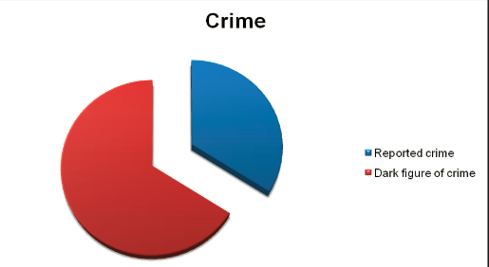
Comparison between London and New York
“Can it really be true that the murder rate in the UK capital is now worse than an American city where not so long ago people were being killed at a rate of six a day?”
- Key question: How valid is this comparison, and what was the truth behind the statistics?
- What is the ‘dark figure of crime’?
- Can you trust ‘official statistics’?
- Why are not all crimes reported or recorded?
- Are police ‘massaging’ statistics?

