**Sentencing Offenders**

**‘Punishment inexpedient’-not appropriate for the crime**

A **discharge** is a type of sentence where no punishment is imposed

An **absolute discharge** is an unconditional discharge where the Court finds that a crime has technically been committed, but that any punishment of the defendant would be inappropriate, and the case is closed.

A **conditional discharge** is an order made by a criminal court whereby an offender will not be sentenced for an offence unless a further offence is committed within a stated period.

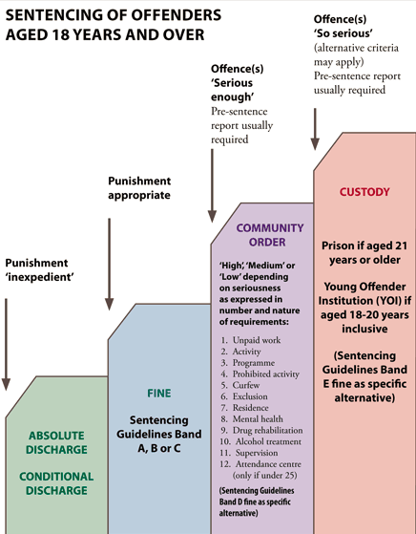

**Task 2:**

* What is mitigating factors? (page 89)
* Can you think of any crimes that might result in an absolute, conditional discharge or fine?
* What types of requirements are made under a community sentence?
* When is custody/prison usually given as a punishment? Why?