List the differences between a magistrates’ court and a crown court (page 88-89). What is the maximum sentence that can be imposed in each court?

**When is a jury used in a crown court case?**

**3.5 Criminal Courts**

**A Magistrates Court**

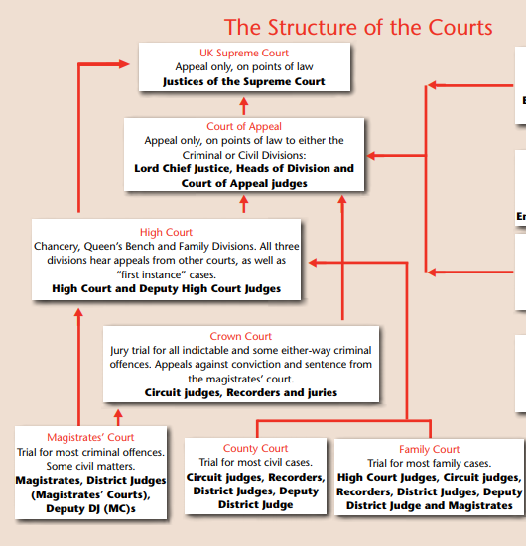

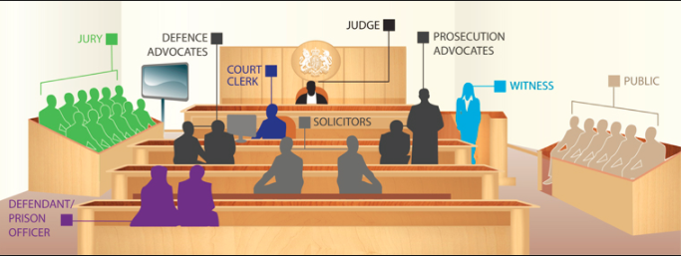

The arrows in the diagram ‘the structure of courts’ show the process of appeal in you are not happy with the court’s decision.

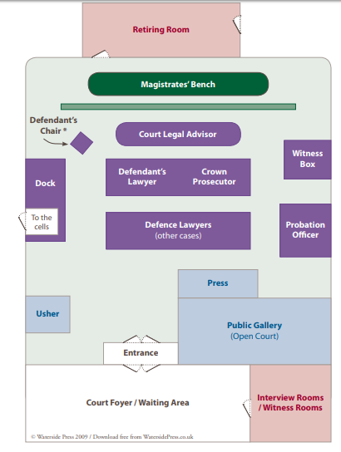

**A Crown Court**