Year 11 Cover: Tuesday 17th October 2017: Miss Nelson
LO: to understand the UK criminal court system
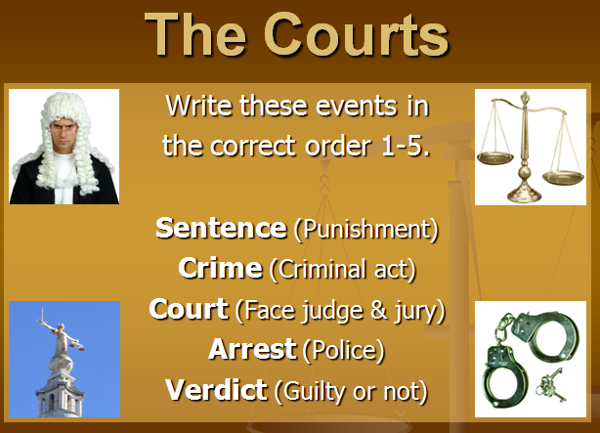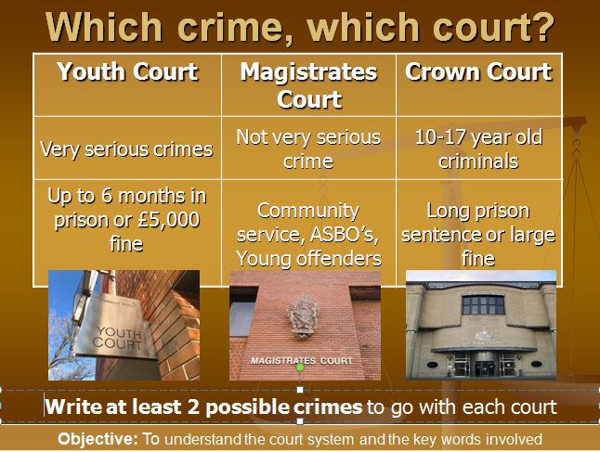
TASK:
- Put the events in the correct order 1-5
- Match the correct statements with each type of court and write at least 2 possible crimes to go with each court
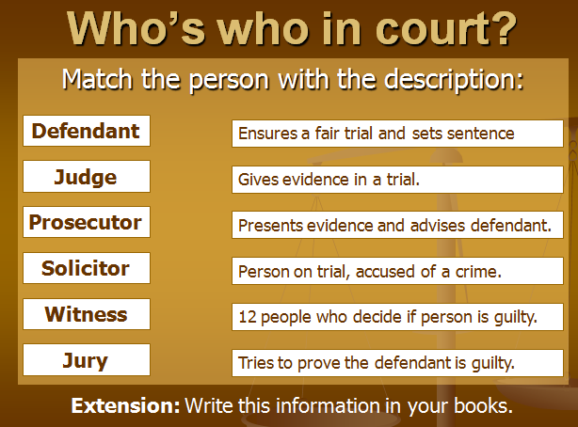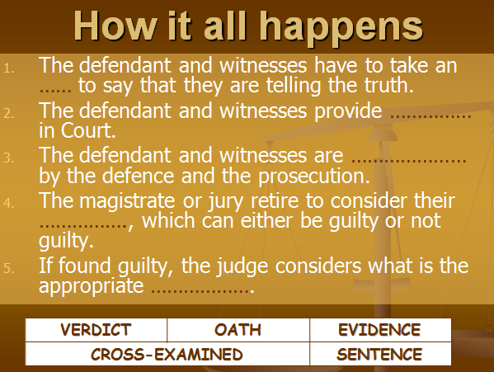
- Match people who work in court with the correct description
- Complete the gap-fill exercise entitled ‘how it all happens’ in your books.
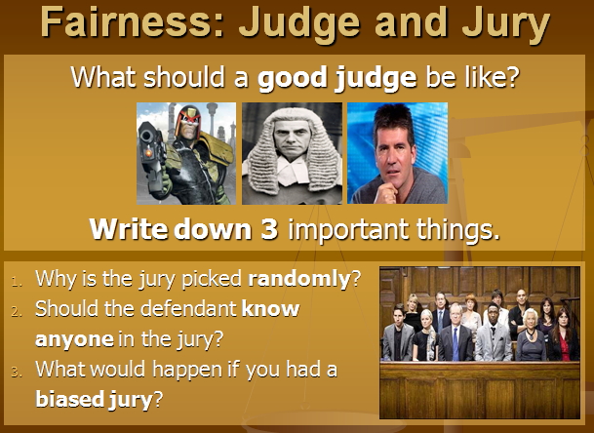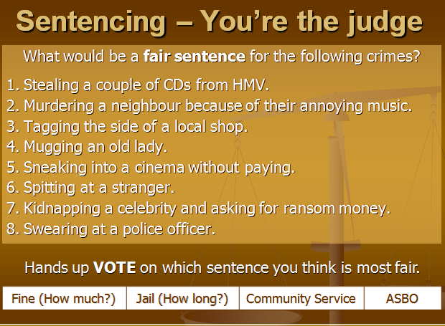
- Answer the questions on ‘Fairness: Judge and Jury’.
- For each crime write down a fair sentence.
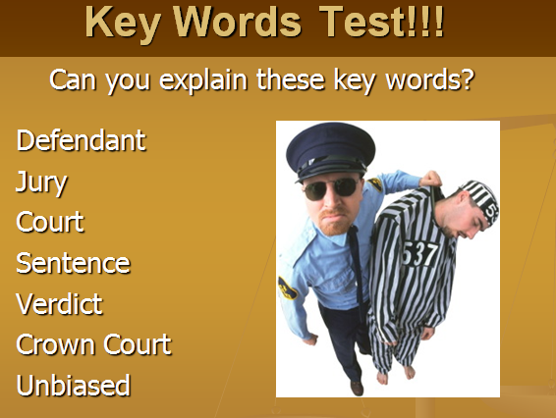

Plenary
- What are the different types of criminal court?
- Can you explain each of the key words?
Test your partner!

