Task 2: Who puts the law into practice?

3. The Criminal justice system is large and complex. There are many roles within
it. Complete the ‘roles within the CJS fact find sheet’ by walking around the room
to complete each role.

Solicitors

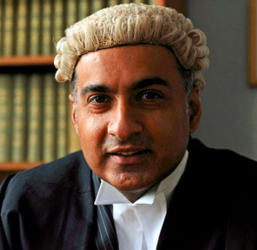
Task 2: Complete the check your understanding questions on page 87.
Homework: research who can be called for jury service and what serving on jury involves.
Barristers

Probation Officers

