Task 2: Who puts the law into practice?

3. The Criminal justice system is large and complex. There are many roles within
it. Please visit https://www.cps.gov.uk/publication/glossary and complete
the research sheet. Research entry requirements (age, qualifications etc.) of
three roles within the CJS.
Solicitors

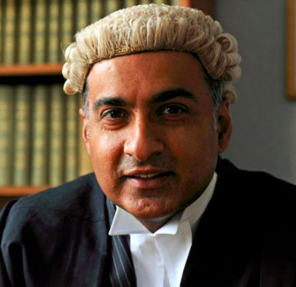
Task 2: Complete the check your understanding questions on page 87.
Homework: research who can be called for jury service and what serving on jury involves.
Barristers

Probation Officers

