**3.2: Task 1: What is Law?**

**Starter: Complete the quiz. How much do you know about the law?**

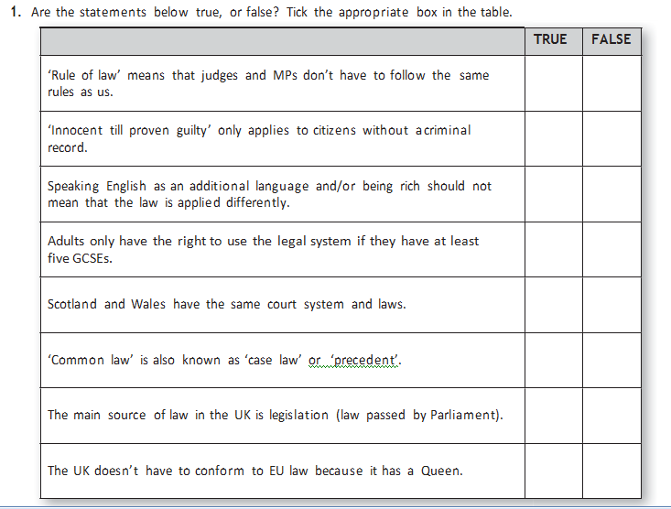

**offence ,innocent , law , right ,equally ,evidence ,court, legal**

**Law protects our rights and freedoms**

* **Innocent until proved guilty**

Anyone who is brought to______________ is said to be ______________until they are proved guilty. This means that the court must present ________________ to prove that a person is guilty beyond reasonable doubt.

* **Equality before the law**

The____________ applies to everyone _________________, whatever their gender, ethnicity, religion, age or disability.

* **Access to justice**

Everyone has the ____________to use the _______________ system whether they have been charged with an _______________ or have been hurt in some way.

**Task 1: complete the gap-fill exercise. What is law?**