**Worksheet 1.8b: How are groups and communities affected by inequality and discrimination?**

Read the text below about how groups and communities can be affected by inequality and discrimination.

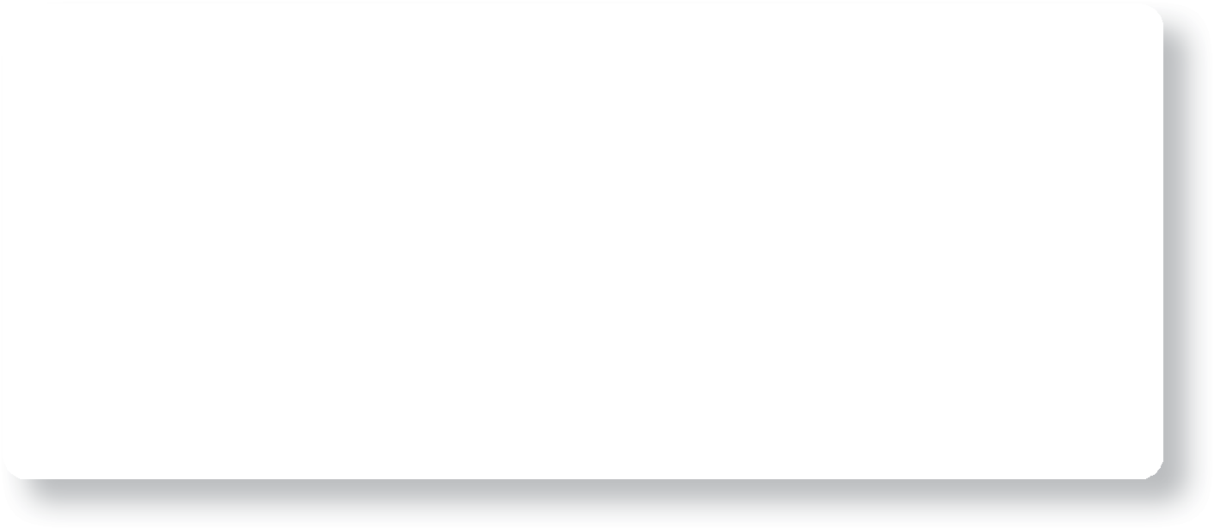

**1. The jobs market does not provide equal opportunities:** bosses may make assumptions and only give jobs to certain people. For example, a woman comes to an interview wearing an engagement ring. The prejudiced interviewer immediately turns against her, assuming she’ll get pregnant soon and will need time off.

**Theme A Living together in the UK**

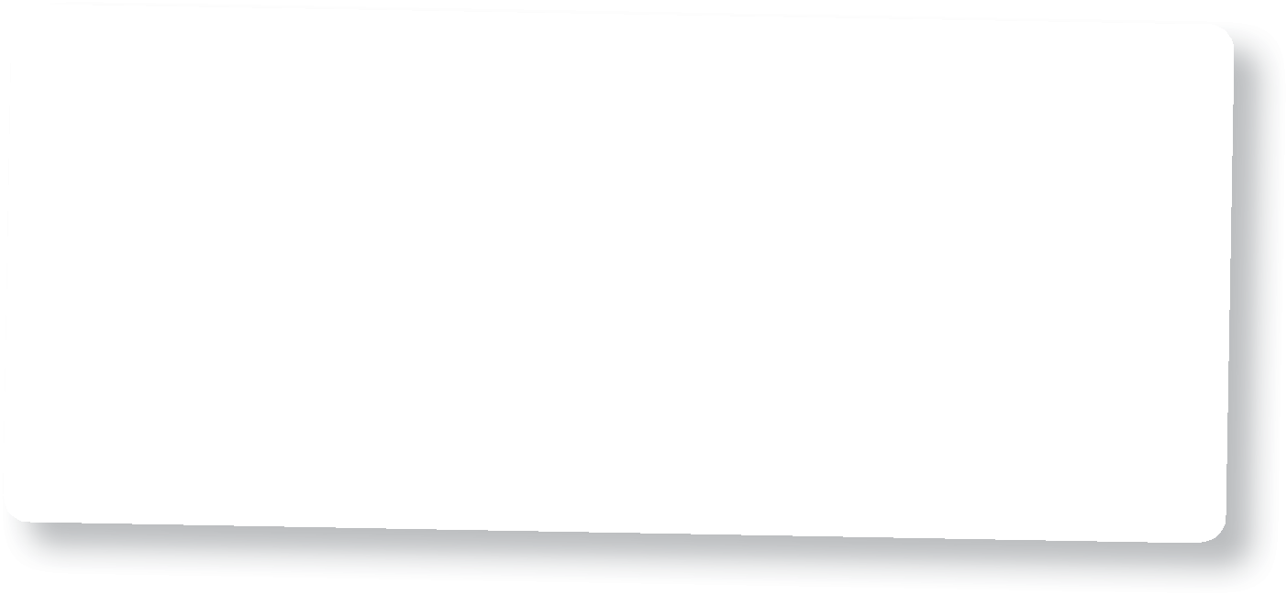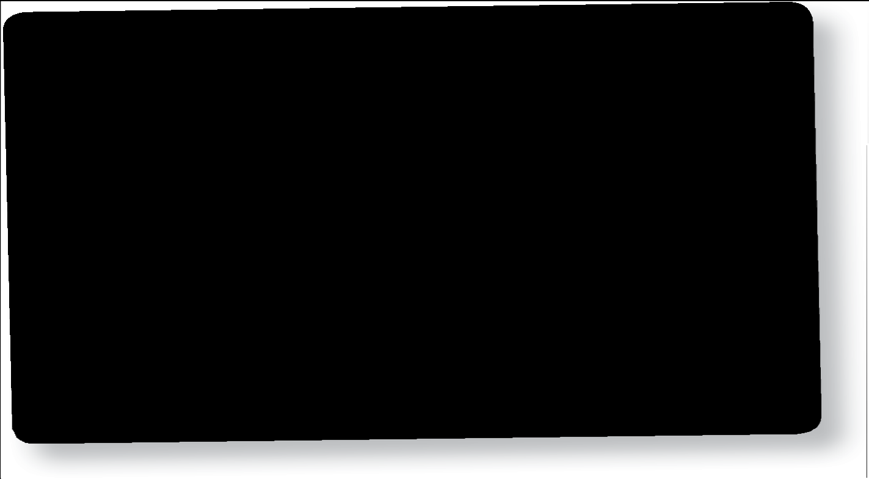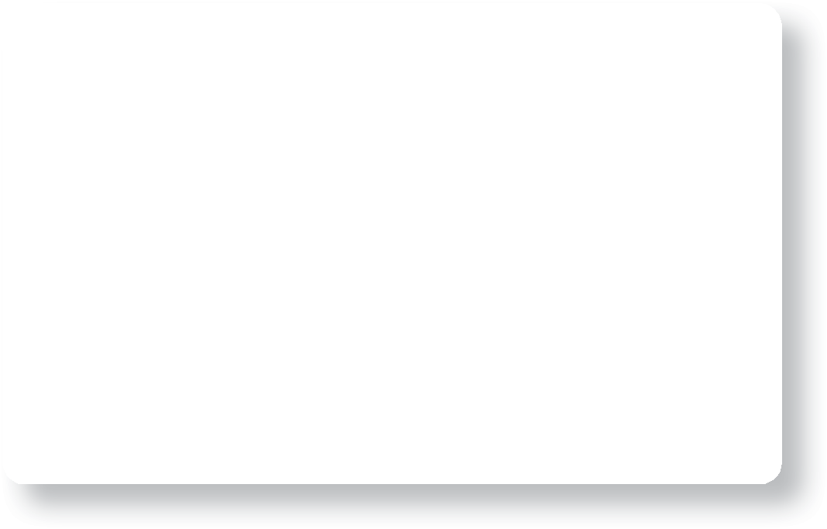

**6. Mental suffering:** illnesses like depression are more common in groups who experience inequality and discrimination. Many teenagers from minority groups feel under

a lot of pressure to ‘fit in’ with wider society. This can lead to low confidence, anxiety and self-harm.

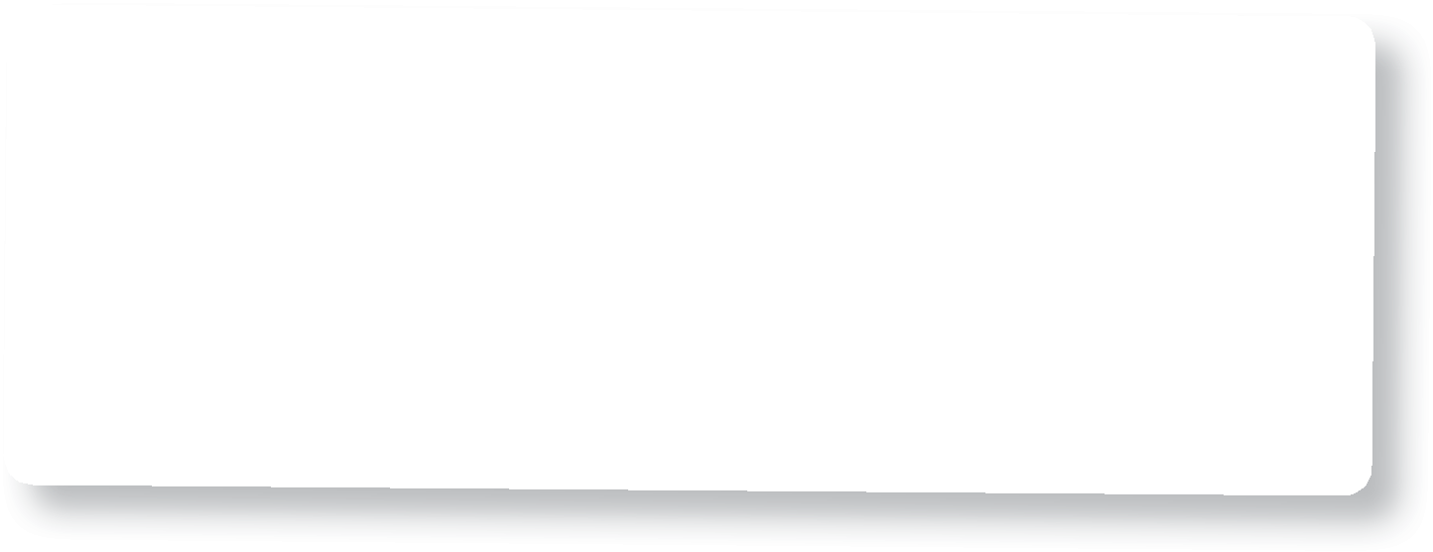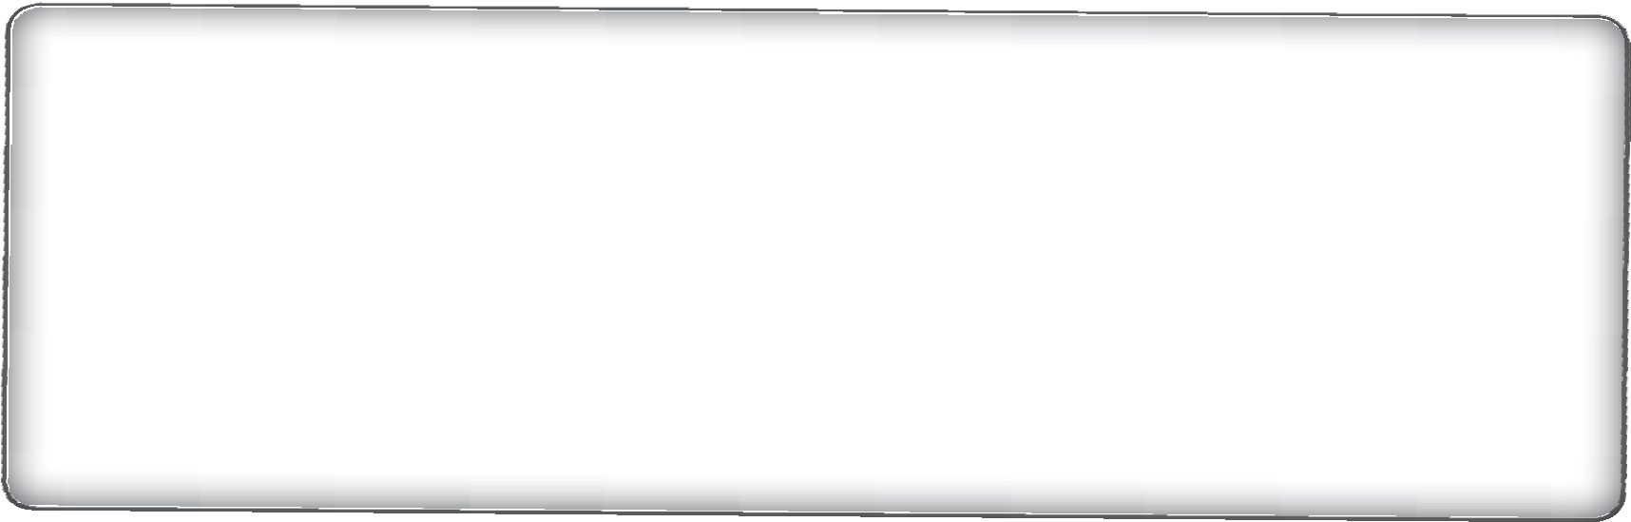

**5. Physical suffering:** violent attacks may occur in certain buildings (gay pubs, synagogues, Catholic schools etc.). People can be seriously hurt, or even killed. Victims may feel frightened about reporting the crime because they’re worried that this could put them in further danger.

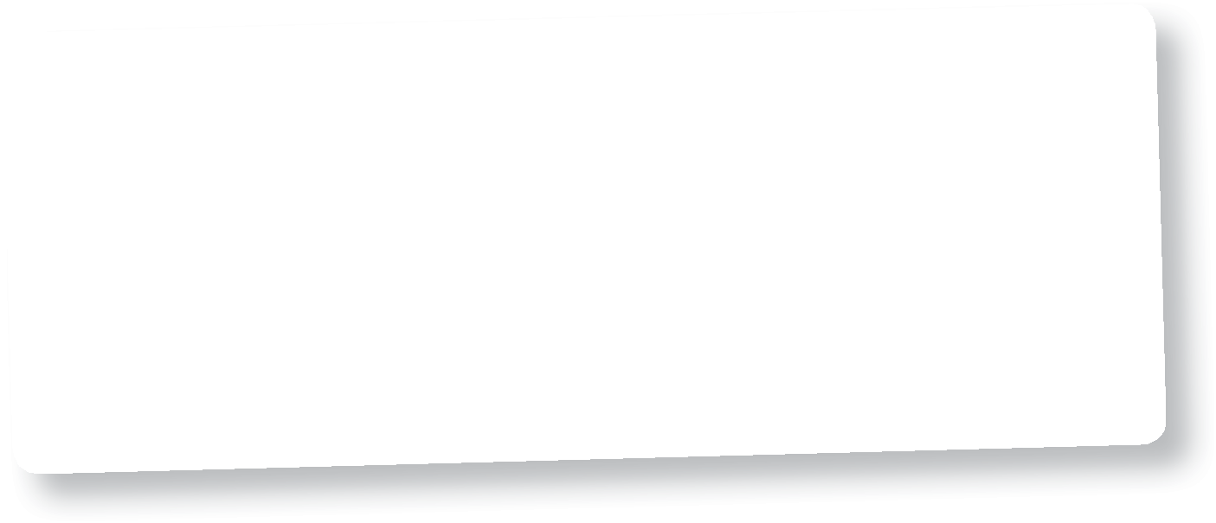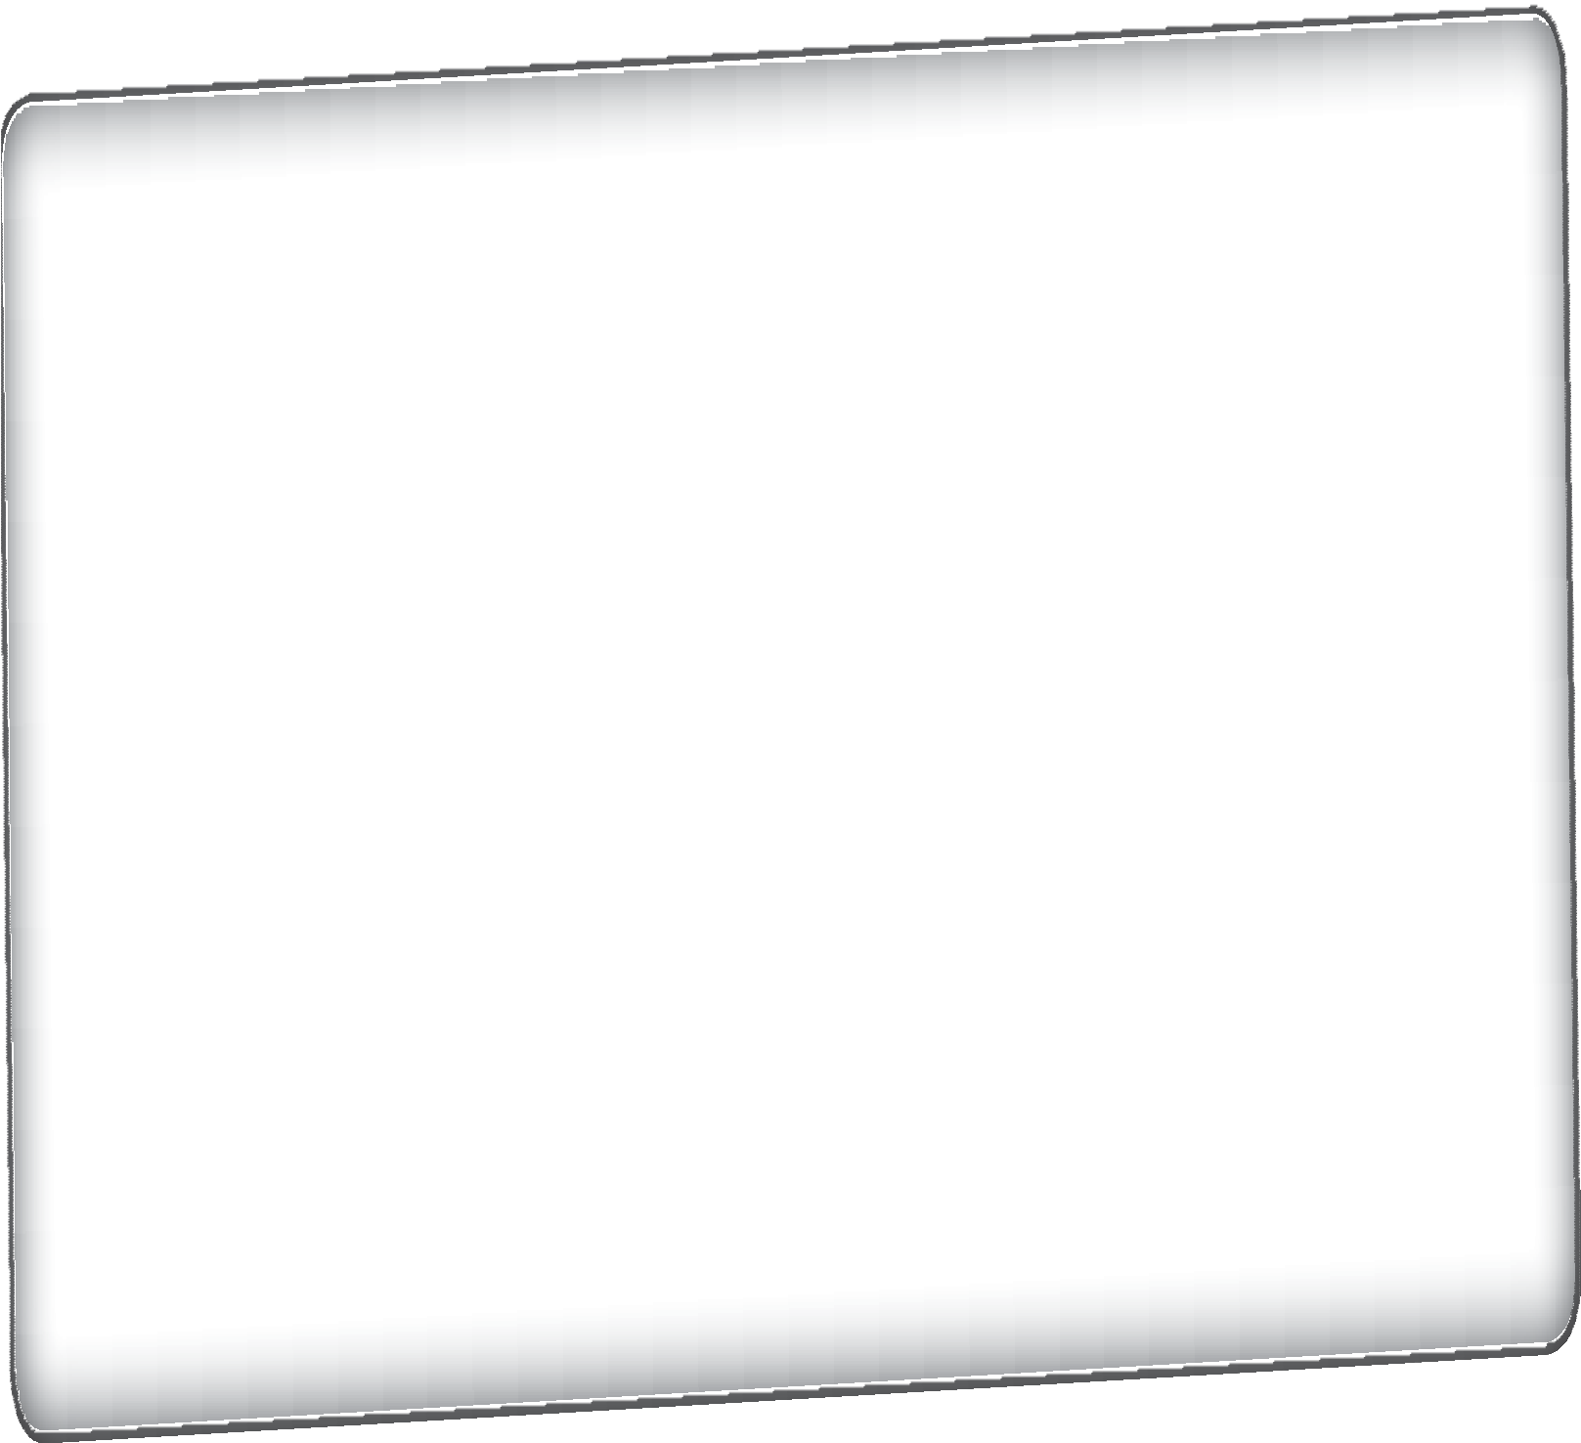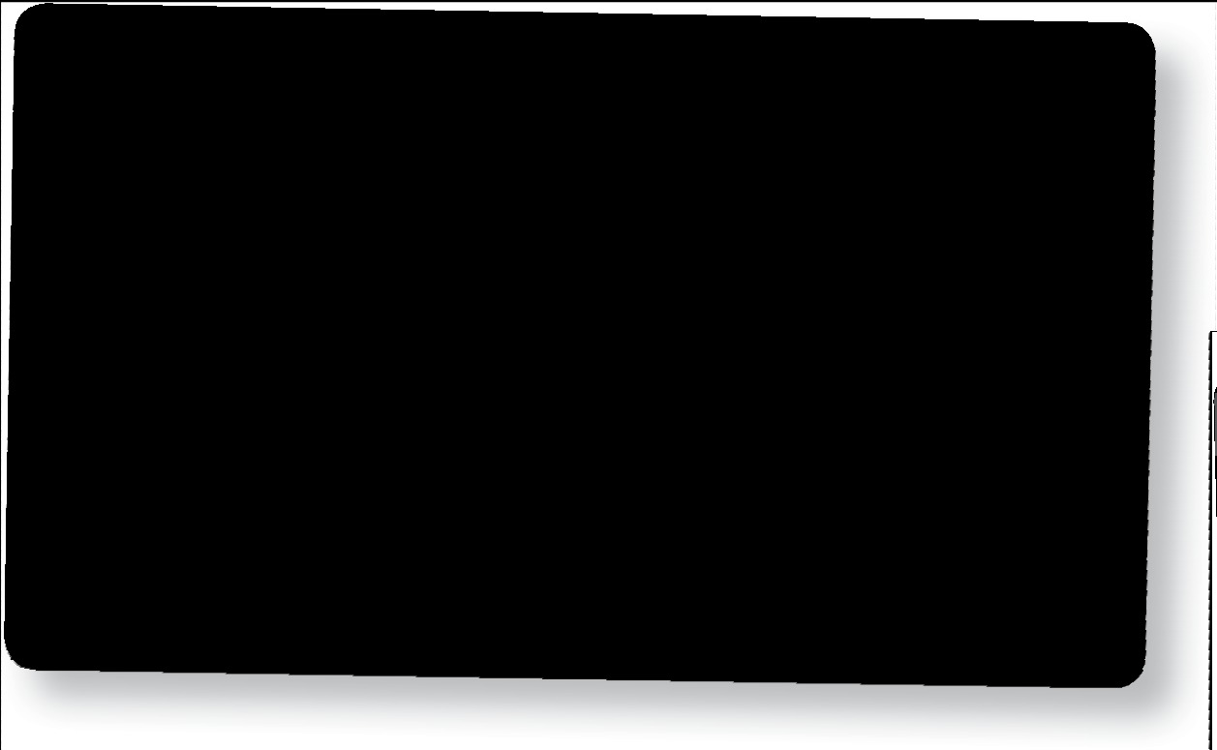

**3. Media stereotyping:** newspapers and TV programmes mostly report negative stories about certain groups. For example, terrorists claiming to be Muslim are

constantly reported in the news. This can be misleading, as terrorists in any community only represent a tiny percentage of that community.

**4. Children don’t have equal access to education:** teachers may give more attention to certain pupils. For example, Sammie’s teachers always praise her because her homework is great. However, it’s only great because (unlike Rachel, another pupil) Sammie has a computer at home and has a private tutor.

**7. Neighbourhoods become tense:** trust can break down between people living close to one another. Citizens may blame each other for problems in society (such as unemployment). People repeat what they’ve heard without having any evidence, e.g. ‘The Polish are taking all our jobs’.

© HarperCollins*Publishers* Ltd 2016 **33**