Dreadlocks ban school backs down after court action threat

A rastafarian boy who was told by his school to cut off his dreadlocks has won the right to keep his hairstyle and return to class after a legal row.
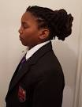
Chikayzea Flanders was told his hair breached the appearance policy at The Fulham Boys’ School on his first day there last year. The 12-year-old, whose family are Rastafarians and all have dreadlocks, was taught in isolation and then left the school.
Despite the outcome he has chosen not to return to the school. His mother, Tuesday Flanders, made an official complaint to the school but found the response to be unsatisfactory and judicial review proceedings were launched. A spokeswoman for the Equality and Human Rights Commission (EHRC), which funded the legal action, said the case was settled before it reached the High Court.
She said: “Chikayzea Flanders and his mother have now reached an agreement with Fulham Boys’ School, with both sides accepting that the school’s enforcement of its uniform policy and ban on dreadlocks resulted in indirect discrimination.”
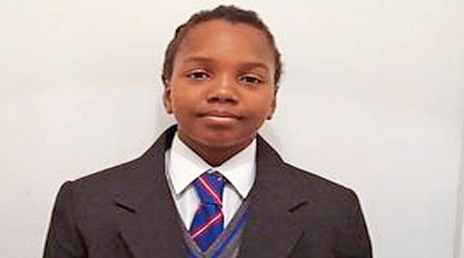
The spokeswoman for the EHRC said Chikayzea was welcome to return to Fulham Boys’ School provided his dreadlocks were tied up or covered with a cloth.
Chikayzea, now 13, currently attends nearby Hurlingham Academy and does not plan to return to The Fulham Boys’ School. Mrs Flanders welcomed the outcome but said her son’s hair was always tied back.
She added: “The whole thing is not a fashion for me or my family. All my boys have the same dreadlocks, my partner has the dreadlocks, my hair is down to my ankles. Why would I change it for a school? What message am I sending for my son? Am I saying it’s all right for people to dictate your religion and beliefs — what sort of society is this?”
She added: “I didn’t want to take legal action. I pleaded with the school and tried to educate them. Other people spoke to them and sent them letters explaining the meaning of my son’s hair.
“I didn’t want my son’s face splashed all over the paper. It’s not right that parents have to go to this sort of length to get justice.”
She said Chikayzea was badly affected by the case and took some time to settle at his new school but is now happy there. He is fine... the school has welcomed him and accepted him for who he is.”
The Fulham Boys’ School uniform policy states that hairstyles should be of a “conventional nature” and dreadlocks are specifically banned. The maximum hair length is above the collar. Head Alun Ebenezer said he could not comment on the case but added: “The complaint has been dealt with under our published complaints procedures. We continue to rigorously enforce our policy and uphold the distinctive ethos of the school.”
EHRC chair David Isaac said: “At the heart of this issue is a young boy who is entitled to express his religious beliefs and access an education... no child should be prevented from attending their chosen school because of inflexible uniform policies.”

