**Worksheet 1.17b: Obeying the law and respecting each other**

1. Read the speech bubbles below.

**B.**

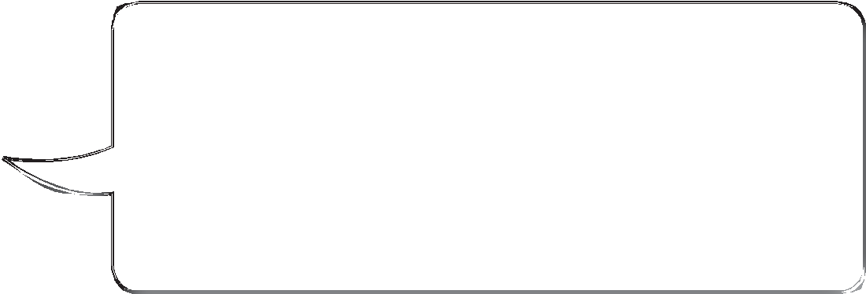

**A.**

I’ve got loads of money, so I don’t

bother following speed restrictions.

If I get caught speeding, I’ll just pay the fine. I won’t even notice the money leaving my bank.

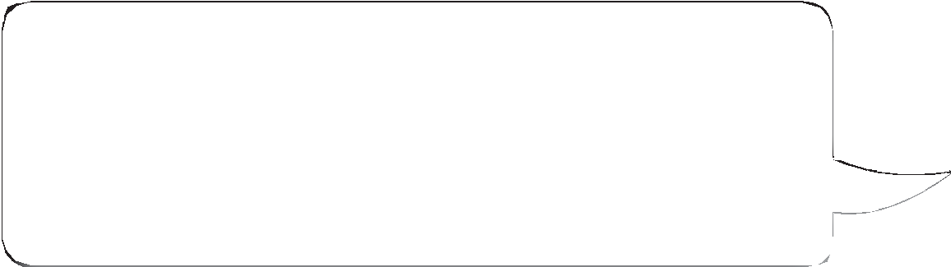

I sell drugs even though I know they’re bad for people. I don’t think it’s a big deal because I never sell to anyone who looks under 14.

**D.**

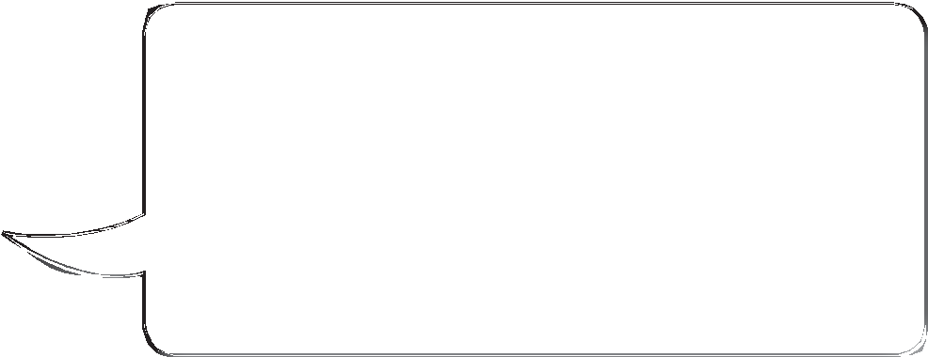

**C.**

I work for myself. I pretend

not to earn much, because I don’t want to pay income

tax. I’d much rather spend the money on my three children.

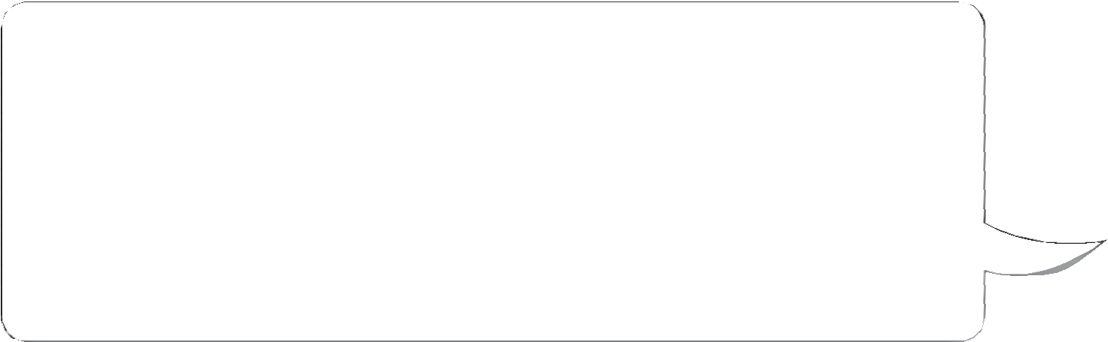

Women have been put down by men constantly over the years. I’ve decided that enough is enough! I’m a teacher and I definitely treat my female students better. I hate men and boys – I’m not going to pretend to be someone I’m not, just because I’m at work.

**F.**

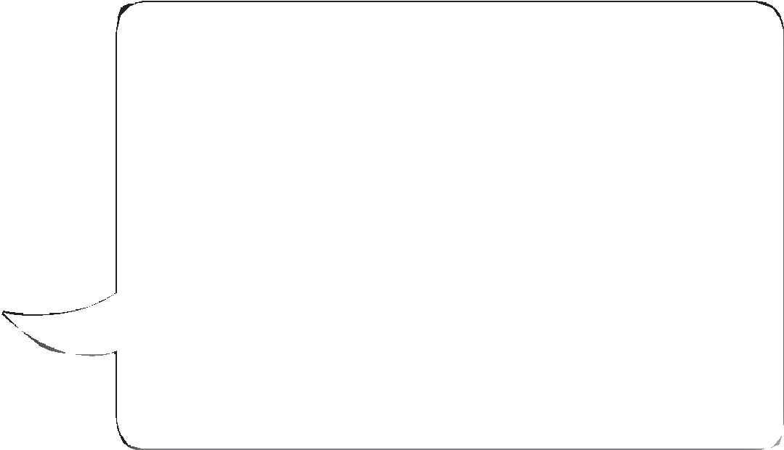

**E.**

I own a restaurant. I like my job,

but I’m not a fan of food hygiene laws. I don’t follow them properly because it takes ages

to clean things properly. It’s also expensive to throw away food just because it’s out of date.



I have been brought up to have no respect for atheists. Atheists are clearly not as intelligent as people who have a religion. They should not hold positions of power or responsibility in society.

**H.**



**G.**

I got sick of this couple next

door who kept asking me to move my motorbike. I decided to punch the bloke – it’s the only way to shut him up!

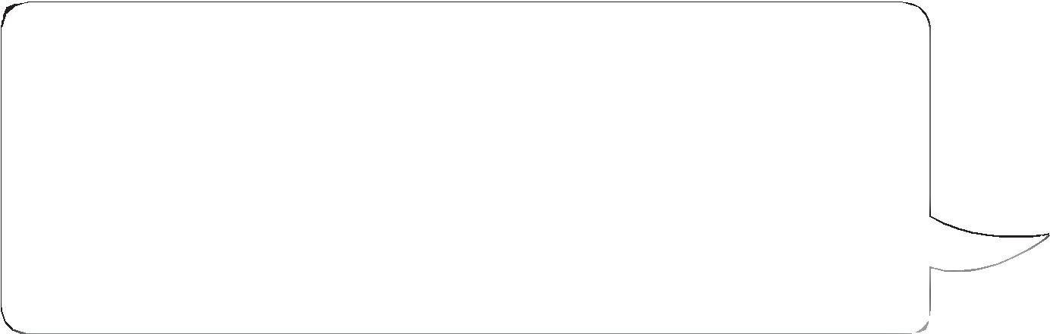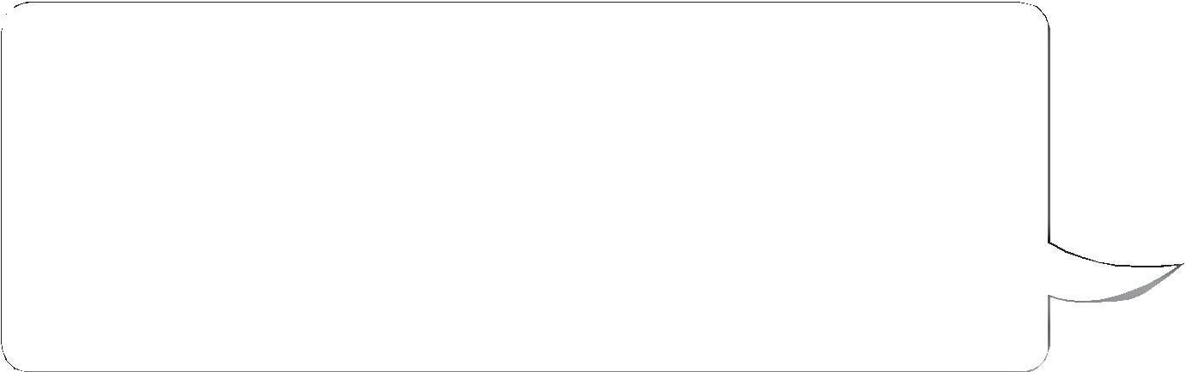

I’m not supposed to smoke in the work van, but it’s pathetic that the government babysits us like that. One of my colleagues, who has asthma, asked me to stop smoking when she’s in the van. She needs to grow up and stop believing all the rubbish that scientists tell us.

**J.**

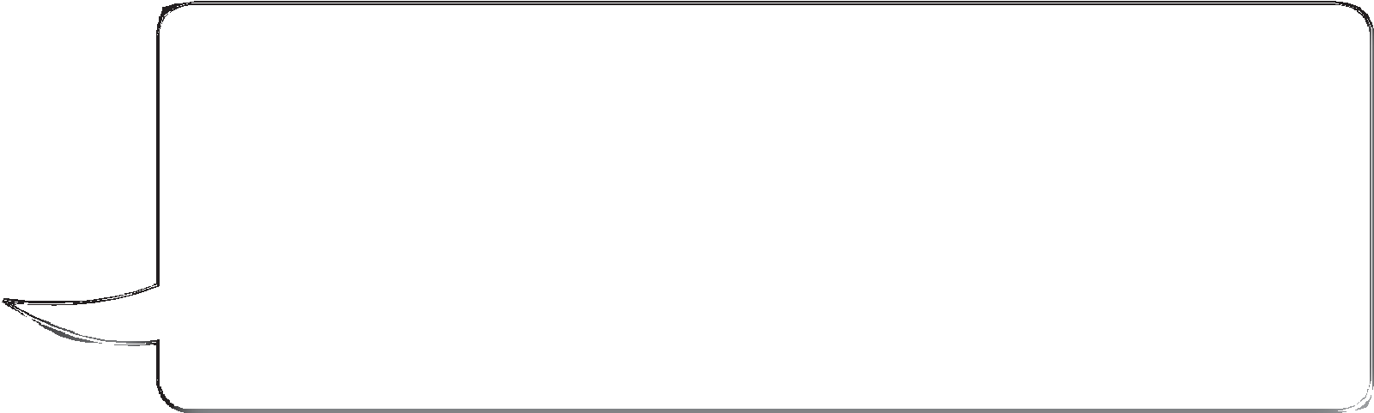

**I.**

I help myself to a lot of stuff in

supermarkets. Supermarkets are so rich that it won’t make any difference to them if I take a few bottles of wine, or some steaks, every few days. It’s only stealing if you take stuff from a small local shop.

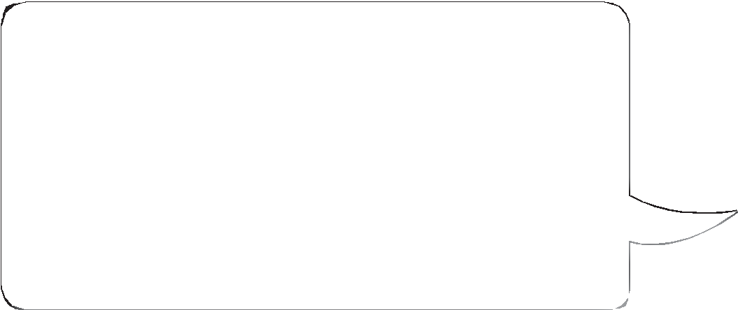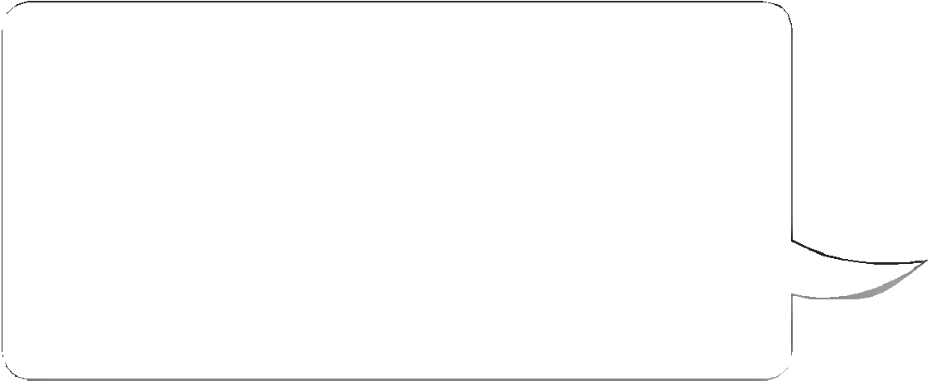

I have no respect for white people, because I was fostered by a white woman and she didn’t treat me well. I don’t see why

I should respect people if I don’t get shown respect by them.

**K. L.**

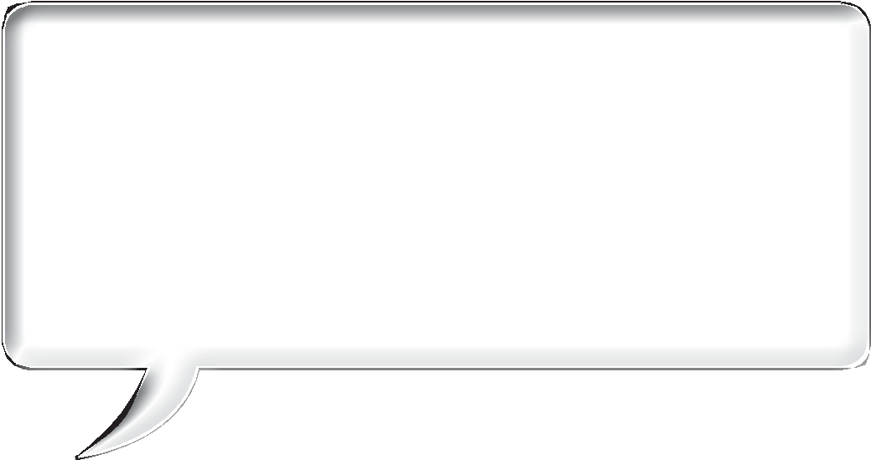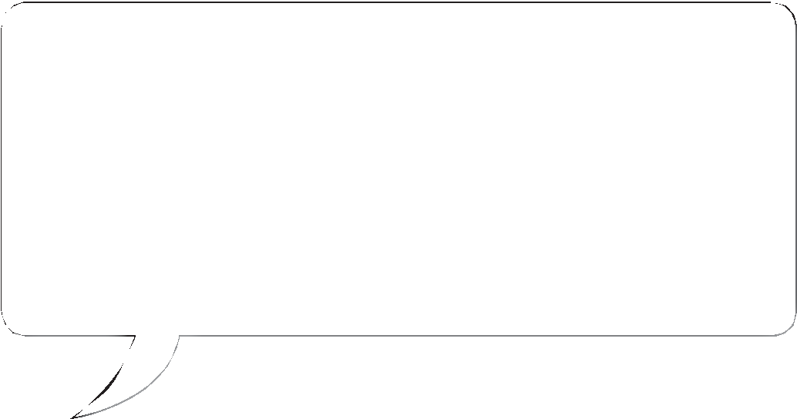

Being a landlord is stressful, so I try not to make life harder for myself.

I choose tenants who’ll put up with anything for low rent. For example, I don’t bother with fire exits, or with having safety checks on boilers.

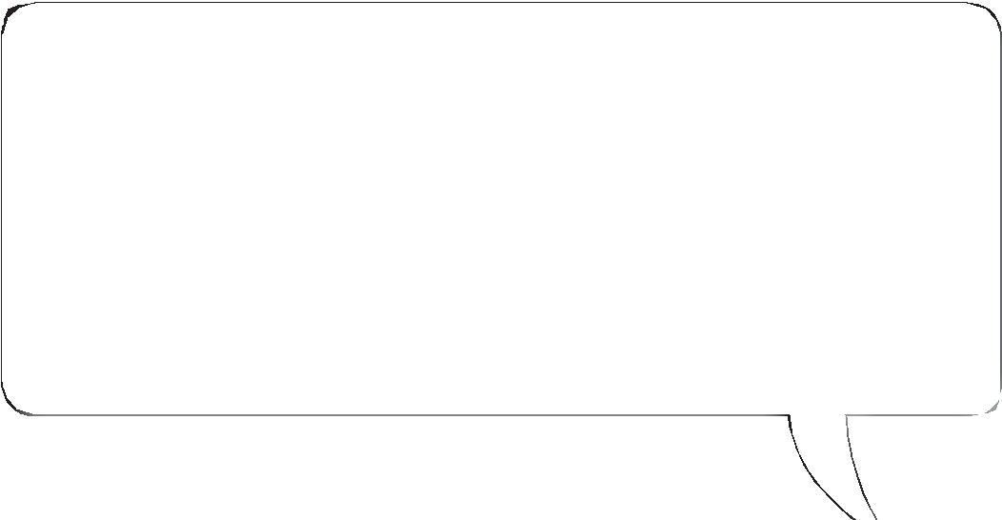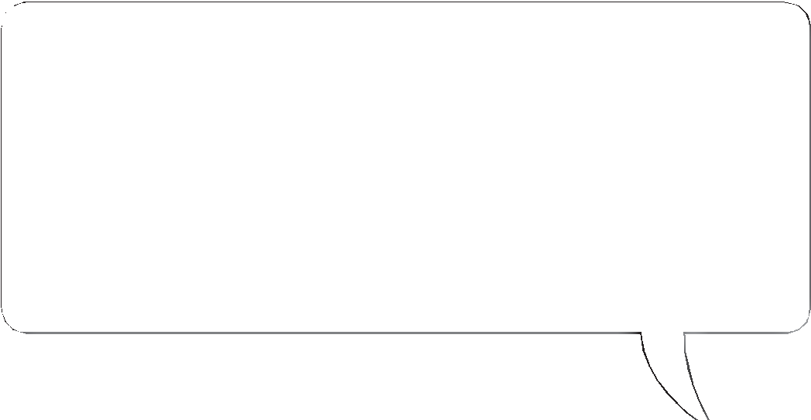

I run a hotel. I have to let gay people stay as I’d be breaking the law otherwise. I make sure gay guests feel really unwelcome though, to stop them coming back. For example, I tell staff to give them really bad room service.

1. In small groups, discuss: *What damage can individuals like this cause to society?*

**Theme A Living together in the UK**

© HarperCollins*Publishers* Ltd 2016