Worksheet 1.12b: How are children’s rights connected to the Magna Carta?

The diagram below shows some of the rights in the UN Convention on the Rights of the Child (1989). Read these and then answer the questions below about how children’s rights are connected to the Magna Carta.

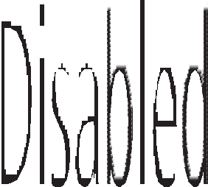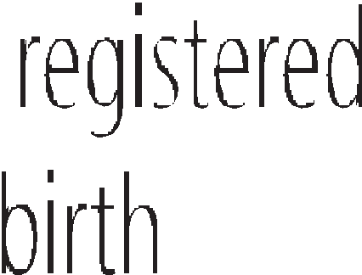

- How well does the UK succeed with article 42 (children should be taught about their rights)?

- Which of the ten articles above do you think is the most important today to under-18s in the UK? Why?

- The Magna Carta set out to guarantee justice. How does the UN Convention on the Rights of the Child support justice for under-18s?

- The Magna Carta also wanted to stop ‘arbitrary rule’ (unfair decisions that are rushed through with little thought). How does the UN Convention on the Rights of the Child help under-18s with this?

Theme A Living together in the UK
© HarperCollinsPublishers Ltd 2016

