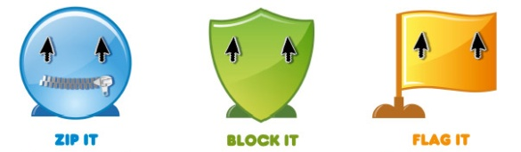
E-Safety Situations
Situation One:  Your best friend tells you that she has been talking to a new friend on what’s app. You don't recognise their name and your friend tells you she/he is going to meet up with this new friend on Saturday. | Situation Two:  A couple of your friends have started to send texts to another pupil which are making this person upset. They ask you to send one from your mobile phone.
Situation Three:  You have recently got a Facebook site and have received some requests from people you don't know asking if they can be your friend. | Situation Four:  You look at a friend's profile on Facebook and you can see where they live, when they were born, their mobile number and there is a picture of them in their school uniform.
Situation Five:  Your friend has found out the password to your email account at school. Your friend wants to be noticed by a couple of cool students so she has passed your password them and now they are sending you nasty messages. | Situation Six:  You have uploaded a picture of yourself onto your Facebook site and now some students at school have downloaded your picture, made changes and started sending them to other people at school.

Situation One: | Situation Two:
Situation Three: | Situation Four:
Situation Five: | Situation Six:
E-Safety Solutions

