YEAR 7 CITIZENSHIP

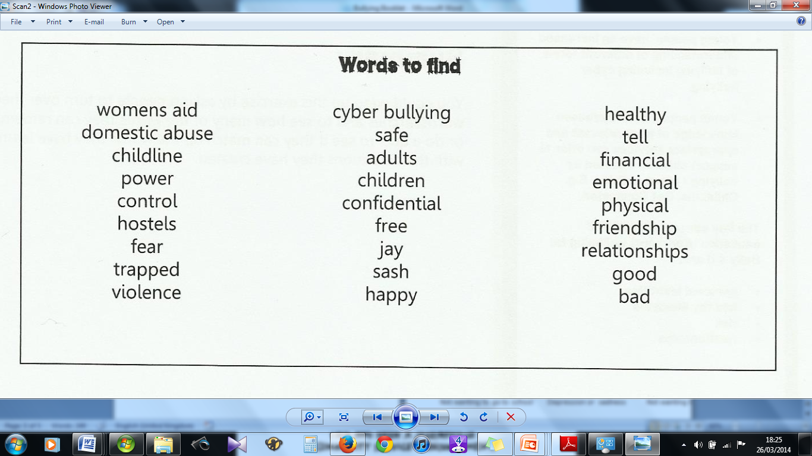
The 4 types of Bullying
Verbal bullying – name calling or making nasty comments or jokes based on sexuality, appearance, race, disability or religion.
Indirect bullying – being ignored, dirty or intimidating looks or gestures, giving people the evil eye, made to feel like an outsider or spreading rumours.
Physical bullying – punching, being spat at, making people do things they don't want to do, having belongings damaged or stolen, making people feel uncomfortable or scared.
Cyber bullying - sending nasty or threatening texts or e-mails, making threatening phone calls, taking humiliating pictures or video clips and sharing them with others, or horrible comments or threats placed on Facebook.

The 4 types of Bullying
Verbal bullying – name calling or making nasty comments or jokes based on sexuality, appearance, race, disability or religion.
Indirect bullying – being ignored, dirty or intimidating looks or gestures, giving people the evil eye, made to feel like an outsider or spreading rumours.
Physical bullying – punching, being spat at, making people do things they don't want to do, having belongings damaged or stolen, making people feel uncomfortable or scared.
Cyber bullying - sending nasty or threatening texts or e-mails, making threatening phone calls, taking humiliating pictures or video clips and sharing them with others, or horrible comments or threats placed on Facebook.

The 4 types of Bullying
Verbal bullying – name calling or making nasty comments or jokes based on sexuality, appearance, race, disability or religion.
Indirect bullying – being ignored, dirty or intimidating looks or gestures, giving people the evil eye, made to feel like an outsider or spreading rumours.
Physical bullying – punching, being spat at, making people do things they don't want to do, having belongings damaged or stolen, making people feel uncomfortable or scared.
Cyber bullying - sending nasty or threatening texts or e-mails, making threatening phone calls, taking humiliating pictures or video clips and sharing them with others, or horrible comments or threats placed on Facebook.

