Name : Class:
Children’s rights
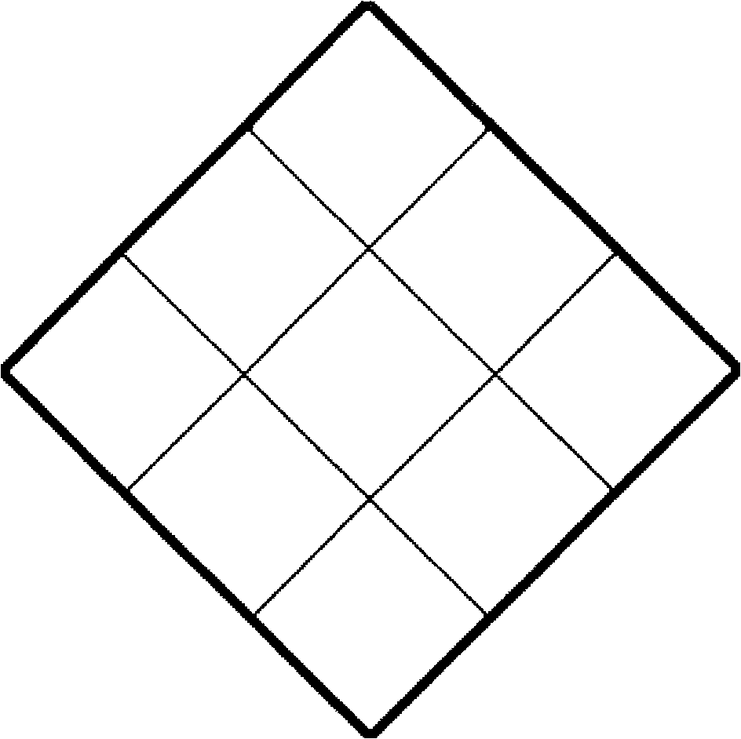
- You have the right to think what you like
and be whatever religion you want to be
- You have the right to make friends
- You should not be put in prison
- You have a right to good health
- You have a right to education
- You have the right to play
- You have the right to collect information
- You have the right to food, clothes
and a place to live
- You have the right to enjoy your own culture

Task: Explain three of the choices you have made. Why are they important?
__________________________________________________________________________________________________________________________________________________________________________________________________________________________________________________________________________________________________________________________________________________________________________________________________________________________________________________________________________________________________________________________________________________________________________________________________________________________________________________________________________________________________________________________________________________________________________________________________________________________________________________________________________________________________________________________________________________________________________________________________________________________________________________________________________________________________________________________________________________________________________________________________________________________________________________________________________________________________________________________________________________________________________________________________________________________________________________________________________________________________________________________________________________________________________________________________________________________________________________________________________________________________________________________________________________________________________________________

